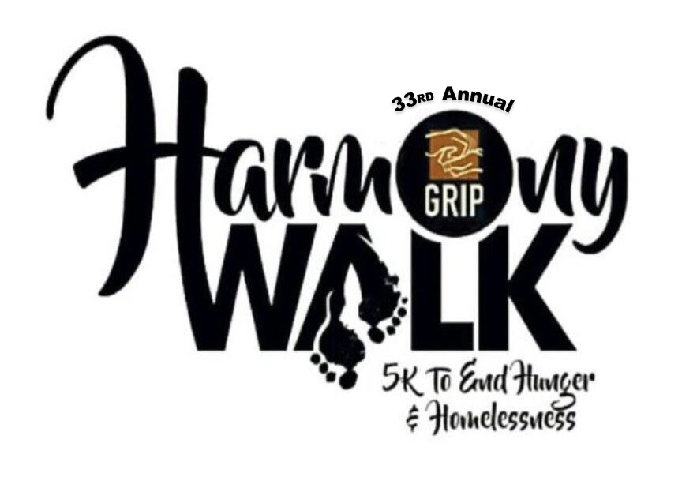

Team Name: ___________________________________

Greater Richmond Interfaith Program
165 Twenty Second Street
Richmond, CA 94801
(510) 233-2141 Fax (510) 233-7127
www.gripcares.org

Role of the Coordinator

- To act as a liaison between your congregation/organization and GRIP in all matters regarding the 33rd Annual Harmony Walk to End Hunger and Homelessness.

- To let your congregation/organization and its members know the purpose of the 33rd Annual Harmony Walk to End Hunger and Homelessness.

- To secure commitments from your family, friends, community, and congregation/organization to participate in the Walk as Walk financial sponsors, donors, and Walkers.

- To collect and return to GRIP all funds gathered by yourself and your Team of Walkers.

- To pick up and deliver all T-shirts purchased through you.

- To lead your team of Walkers in the 33rd Annual Harmony Walk on October 26, 2019.

Paperwork and Money Handling

Please keep track of all donors and donations received on your “Walk Pledge Forms” (provided in this packet). You may turn in donations at our GRIP office located at 165 22nd Street Richmond, CA 94801, or turn in donations at the Registration Table on the day of the event.

- COORDINATOR PAPERWORK HANDLING
  - Coordinator must make sure all team members have completed a Registration Form and paid their $40 registration fee (please note that you may also register and pay your registration fee online at www.GRIPCares.org )
  - Collect donations from team members for submission to GRIP

- GIVE EACH WALKER
  - Registration Form
  - Harmony Walk Flyers
  - Walker Pledge Sheet

- VENDOR SPACE
  - Coordinators please explore if your church, business or organization would like to hold a vendor table at the Harmony Walk Event.
    - Complete vendor application
    - Turn in form and payment to GRIP office
  - Coordinators, teach team members to ask of other individuals, churches and businesses who may want to hold a vendor space
    - Collect the organizations vendor application
    - Collect and Turn in the vendor form and payment to GRIP office
- T-shirts
  - For individuals who don’t want to register to walk in the event but would like to purchase a t-shirt, please help the individual(s) complete the TSHIRT order forms.

- TELL EACH TEAM WALKER HOW TO GAIN FINACIAL DONATIONS TO SUPPORT THEIR WALKING EFFORTS

  - Encourage as many sponsorships and donations as possible BEFORE the Walk
on October 26, 2019
  - Checks are preferred over cash
  - Make checks payable to “GRIP HARMONY Walk”
  - Walkers should bring all in-hand donations and sponsor list to GRIP’s main office at 165 22nd St Richmond, CA or bring funds to the registration on the morning of the event October 26, 2019
  - Collect all outstanding pledges promptly after The Walk and return GRIP staff

33rd Annual Harmony Team Pledge Form

Walker Name: __________________________________ Team Name: ______________________________

Address: __________________________________ City: _____________ State: __________ Zip: ________

Email Address: ______________________________________________ Phone: _____________________

Name of Organization/School/Congregation: __________________________________________________

Sponsor Name | Address | City, State, Zip | Phone: | Pledge | Paid
Sample: CJ’s Supply | 510 Richmond Way | Richmond, CA 94555 | 510-233-2342 | $100 | $100

Please bring this form along with your pledge envelope on the day of the Walk.

33rd GRIP Harmony 5K Walk/Run To End Homelessness and Hunger

Registration Form

To Register as a runner/walker:
- Fill out this form completely
- Sign and date the waiver at the bottom of this form
- Enclose your $40 registration payment (covers registration and cost of tshirt)
- Fill out a separate form for each runner/walker
First and Last Name of Runner/Walker: |  |  |  | Date:
Please indicate if you will be: Running Walking
Name of Organization/ Company (if any):
Birthday: | Age: |  | Gender:
Address: (City, State, Zipcode)

Phone: |  | Email:

*Note: shirts will be available for pick up during the Registration booth on the day of the Event

Shirt Size: SM M L XL XXL NONE

Amount Enclosed: $ _________
Mail Entry Forms and Checks Payable to:
Greater Richmond Interfaith Program 165 22nd Street Richmond, CA 94801

Waiver: In consideration of you accepting this entry, I, the participant, intending to be legally bound and herby waive or release any and all right and claims for damage or injuries that I may have against the Event Organizer, GRIP, and all of their agents assisting with the event, sponsor and their representatives and employees for any and all injuries to me or my personal property. This release includes all injuries and/or damages suffered by me before, during or after the event. I recognize, intend and understand that this release is binding on my heirs, executors, administrators or assignees. I certify as a material condition to my being permitted to enter this race that I am physically fit and sufficiently trained for the completion of this event and that my physical condition have been verified by a licensed Medical Doctor. By submitting this entry, I acknowledge (or a parent or adult guardian for all children under 18 years of age) having read and agreed to the above waiver.

____________________________ ____________________________ ____________
Print Signature Date

*Parents Signature for Children under 18 years of age

NO REFUNDS WILL BE ISSUED FOR ANY REASON
33rd GRIP Harmony 5K Walk
T-Shirt Order Form

First Name | Last Name |  | Date:
Name of Organization/ Company (if any):
Address (street, apt/suite #, zipcode)
Phone: |  | Email:

*Note: shirts will be available for pick up during the Registration booth on the day of the Event

How many shirts would you like to order? _________

Shirt | Circle size for shirt
1 | S, M, L, XL, XXL
2 | S, M, L, XL, XXL
3 | S, M, L, XL, XXL
4 | S, M, L, XL, XXL

Amount Enclosed: $ _________

Payments:
Make Checks Payable to:
Greater Richmond Interfaith Program 165 22nd Street Richmond, CA 94801

____________________________ ____________________________ ____________
Print Signature Date

NO REFUNDS WILL BE ISSUED FOR ANY REASON

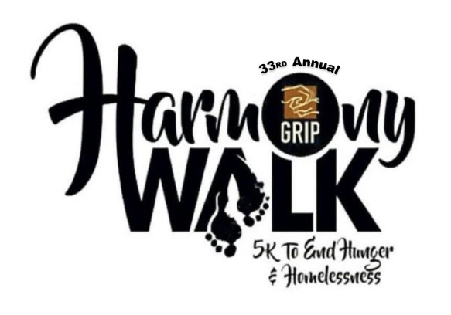
Vendor Application:

Point of Contact Name: |  | Number:
Business/ Organization Name:
Mailing address: city, state, zipcode
Phone: | Fax: |  | Email:
Non Profit I.D Number: |  | Business I.D. Number

Please identify the items you wish to sale/ distribute during the Harmony Walk. ____________________________________________________________________________________________________________________________________________________________________________________

BOOTH FEE:
____ Nonprofits $50.00 ____ Community Business: $75.00

GRIP will provide one (1) table and two (2) chairs for each exhibitor. Each vendor is responsible your table signage, tablecloth and decorations. Vendors must check-in by 8:00 am (not before 7:00 am.)

All vendors must have booth set-up by 9:00 am and dismantled by 3:00 pm on Sat., October 26, 2019.

For questions please call Nicole Jones at (510) 233-2141 ext 320. Please scan and email your completed application to Nicole at NJones@gripcommunity.org

PAYMENT OPTIONS:
Please make checks out to : Greater Richmond Interfaith Program Attn: Harmony Walk
Can be mailed or walked in to the following address: 165 22nd St., Richmond, CA 94801
Vendors can also pay online at www.GripCares.org

I have read and agree to the Vendor Terms and Conditions.

Signature __________________________________________ Date _____________________________

